This is for the acrylic that we used to design the casing. I asked someone to make an AutoCAD of the design and cut it in the Fabshop. The labor fee for CAD of designing the casing is 1,500 (separated from the price of the acrylic).

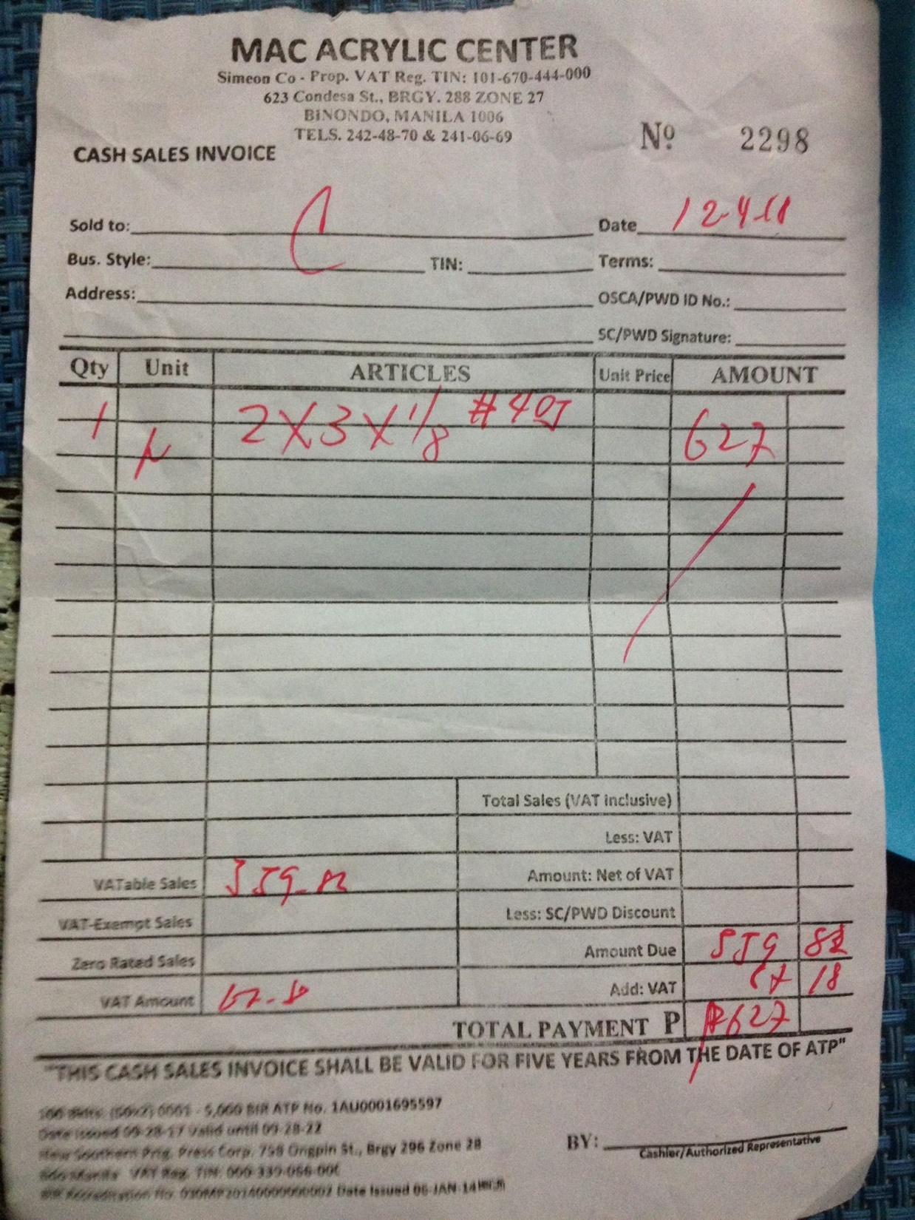

This is the receipt materials used to assemble the cut acrylic. Only the encircled ones. It consists of screws, brass, nuts and push buttons.

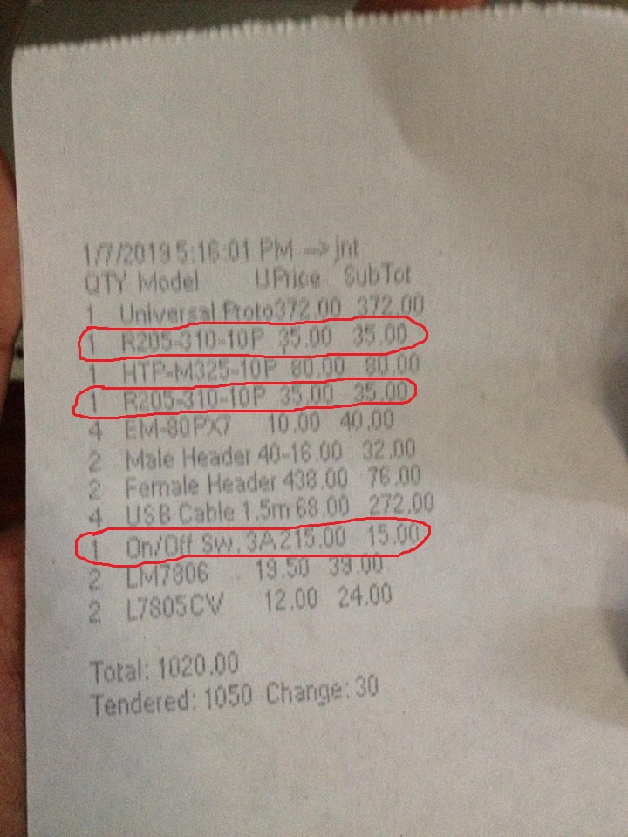

This is the power bank I used. I bought this from my other client because their thesis prototype was already done. It is worth 500.

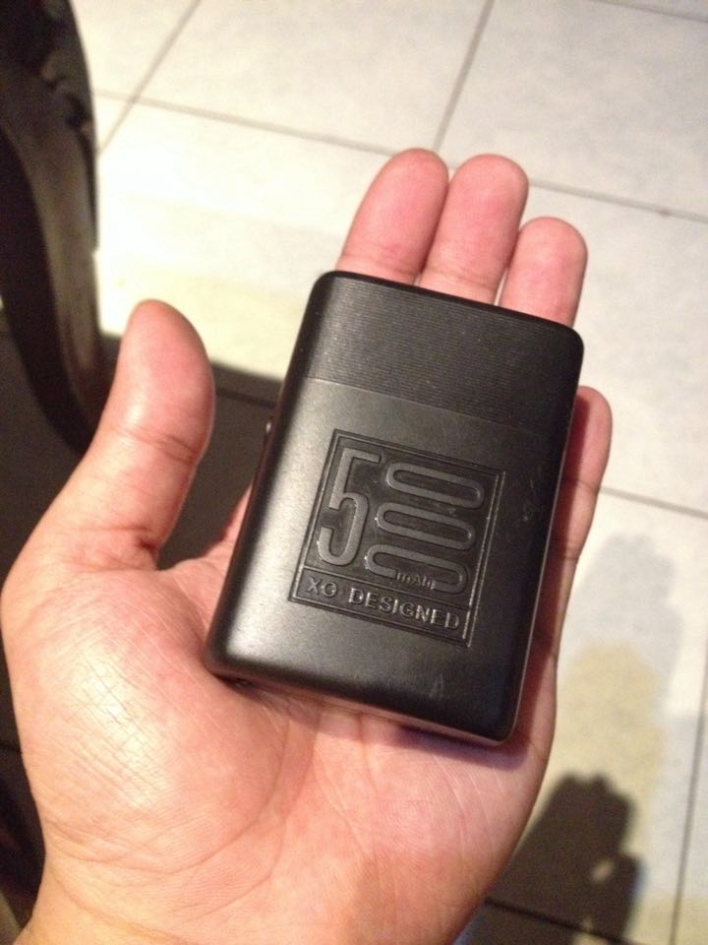

Computing all the materials I used for this project:

* 627+1500+35+35+15+500

Total of 2712.